**FAMAuth Users Guide**

Version 7.0

5/6/2024

Table of Contents

Purpose 4

Guide 5

Section I: Login via eAuthentication 5

Access FAMAuth Portal 5

Select your agency 6

Enter your credentials 6

Section II: Login via Login.gov 8

Access FAMAuth Portal 8

Enter your credentials 9

Section III: Create a Login.gov Account 10

Access FAMAuth Portal 11

Create Login.gov account 12

Section IV: Link with iNAP Profile 22

Link your Login.gov or eAuthentication Account with your iNAP Profile 22

Section V: Create iNAP Profile 26

Request iNAP profile 26

Revision History

|  |  |  |  |  |
| --- | --- | --- | --- | --- |
| Rev # | | Date | Author | Description |
| 7.0 | 5/6/24 | | M. Apicella | Updated with FAMAuth 2.9 |
| 6.0 | 3/22/24 | | M. Apicella | Updated for iNAP 2.12 |
| 5.0 | 1/12/24 | | J. Olson | Updated screen shots from FAMAuth 2.8, and iNAP 2.11. |
| 4.0 | 4/4/23 | | M. Apicella | Updated with FAMAuth 2.6. |
| 3.0 | 12/06/22 | | M. Apicella | Updated with FAMAuth 2.5. |
| 2.0 | 10/27/22 | | M. Apicella | Updated with FAMAuth 2.4 and iNAP 2.7 changes. |
| 1.2 | 8/16/22 | | J. Olson | Updated with FAMAuth 2.3 and iNAP 2.6 changes. |
| 1.1 | 5/12/22 | | J. Olson | Updated with FAMAuth 2.2 changes. |
| 1.0 | 2/24/2022 | | M. Roadifer | Reviewed and approved by Ryan Hunt. |
| 0.2 | 2/22/2022 | | M. Roadifer | Minor updates from internal review. |
| 0.1 | 2/21/2022 | | M. Roadifer | Added flow chart and various edits. Still draft. |
| 0.0 | 2/18/2022 | | M. Apicella | Initial draft. |

# Purpose

The purpose of this document is to guide new users through the steps of accessing applications in the FAMAuth portal. The portal is accessible via desktop or mobile devices. The screenshots in this guide are from the desktop experience. Note the look on a mobile device may slightly differ.

Review the flowchart below to determine which section(s) of this guide apply to you as a user that is accessing a FAM application from the FAMAuth portal for the first time.

# Guide

## Section I: Login via eAuthentication

**This section is for users that have a USDA or DOI PIV card.**

### Access FAMAuth Portal

1. Go to: <https://famauth.wildfire.gov>

**Note: This will be your access point for your FAM application from now on so you can bookmark this page**.

1. Select Government (eAuthentication)

### Select your agency

1. Select USDA or DOI in the ‘Select Agency’ drop down

* 1. Save the agency – recommended for users on their own computer. If on a computer being shared by multiple users, it may be preferable to select No

### Enter your credentials

1. Select “Log In with PIV/CAC”. Can also select “Log In with Password” but this guide describes the use of a PIV card

* 1. Select the certificate

* 1. Enter the PIN

* 1. The Wildland Fire Application Portal is displayed. Find the tile or logo for the FAM application you want to use, click the tile (or logo), and continue to next section of the flowchart

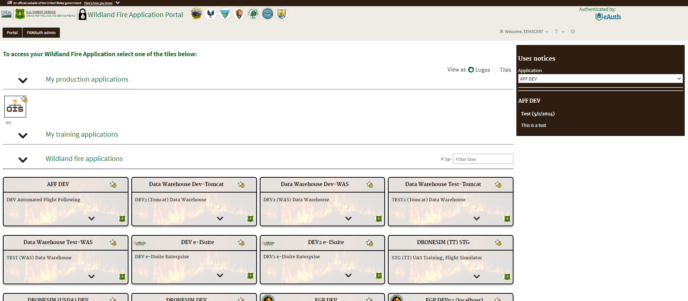

## Section II: Login via Login.gov

**This section is for users that do not have a USDA or DOI PIV card but do have a Login.gov account.**

**This guide assumes that your Login.gov account was setup using text message for the 2nd level authentication. Using other methods will result in different screens than shown below.**

### Access FAMAuth Portal

1. Go to: <https://famauth.wildfire.gov>

**Note: This will be your access point for your FAM application from now on so you can bookmark this page**.

1. Select Public Partners (Login.gov)

### Enter your credentials

1. Enter your Login.gov email address, password and select “Sign in”

**Note: A new one-time security code will be sent to your phone, this is your 2nd level of authentication.**

1. Enter one-time security code sent to your phone. If on a computer that is shared by multiple users, uncheck “Remember this browser”. Select “Submit”

1. The Wildland Fire Application Portal is displayed. Find the tile or logo for the FAM application you want to use, click the tile (or logo), and continue to next section of the flowchart

## Section III: Create a Login.gov Account

**This section is for users that do not have a USDA or DOI PIV card and do not already have a Login.gov account.**

### Access FAMAuth Portal

1. Go to: <https://famauth.wildfire.gov>

**Note: This will be your access point for your FAM application from now on so you can bookmark this page**.

1. Select Public Partners (Login.gov)

### Create Login.gov account

1. **If you have an existing Login.gov account sign into your existing account (see Section II),** else Create a Login.gov Account by selecting ‘Create an Account’

* 1. Enter your email address (**does not need to match you iNAP email address)**
  2. Select your language
  3. Check the ‘Rules of Use’ box
  4. Select ‘Submit’

**Note: An email will be sent to the email address entered in step (a.)**

* 1. Confirm Email
     1. Go to your email account
     2. Find the email from Login.gov
     3. Click on the ‘Confirm email address’ Link within the email that you received

* 1. Create a strong password

**Note: Password must contain at least 12 characters with a good or better strength rating (3 green bars) to continue. Remember your password.**

* 1. Select ‘Continue’

* 1. Select your 2nd level Authentication Method: ‘Text or Voice Message’
     1. We recommend using Text if possible
     2. Do not use web based VOIP phones
     3. Note: If you chose to use a different authentication method, we cannot provide any further guidance for you.
     4. You will be required to use this 2nd level of authentication each time you log into your FAM application.
  2. Select ‘Continue’

* 1. Text or Voice Message Authentications
     1. Login.gov will send you a security code each time you sign in, so ensure you use a phone number you have access to.
     2. Message and data rates may apply. Do Not use web based VOIP phone service.
  2. Enter your phone number
  3. Select Text Message or Phone Call
     1. We recommend Text
  4. Select Send Code.

**Note: The code will expire in 10 minutes.**

* 1. Enter your one-time security code that you received either text or call
  2. If on a computer that is shared by multiple users, uncheck “Remember this Browser”
  3. Select ‘Submit’

**Note: You should see a confirmation from login.gov like the one below that ‘A phone was added to your account’ and the email address associated with your login.gov account.**

* 1. Select ‘Agree and Continue’

* 1. You have successfully created a Login.gov account and the Wildland Fire Application Portal is displayed. Find the tile or logo for the FAM application you want to use, click the tile (or logo), and continue to the next step of the flowchart

## Section IV: Link with iNAP Profile

**This section pertains only to FAM applications that use iNAP for authorization of access and roles: Data Warehouse, e-ISuite, FEPP, IROC, LESO, OIS, SIT209 and WIMS.**

**This section is for users that have an existing profile (or account) in iNAP and are already able to login to the Wildland Fire Application Portal via either Login.gov or eAuthentication.**

### Link your Login.gov or eAuthentication Account with your iNAP Profile

1. On the Wildland Fire Application Portal Dashboard page, find the tile or logo for the FAM application you want to use and click on it.

**Note: If you DO NOT have an existing iNAP account do not proceed – go to section V.**

1. Select “I have an iNAP profile already”, and select “Next”

1. Enter your iNAP email address, and select “Submit”

**Note: iNAP will email your PIN to the email address provided. The email will come from** [**donotreply@nwcg.gov**](mailto:donotreply@nwcg.gov)

1. Enter your PIN that was emailed to you, and select “Submit”

1. Review your profile for accuracy, and select “Save”

**Note: If logged in via Login.gov then under “Linked accounts” it shows you have linked your Login.gov account with your iNAP profile.**

**Note: If logged in via eAuthentication then under “Linked accounts” it shows you have linked your eAuthentication account with your iNAP profile.**

**You will see this page display. You have successfully connected your iNAP profile and Login.gov or eAuthentication account. This is a one-time process. The next time you click the “Access” button on the application tile you wish to use you will be redirected to the FAM application.**

## Section V: Create iNAP Profile

**This section pertains only to FAM applications that use iNAP for authorization of access and roles: Data Warehouse, e-ISuite, FEPP, IROC, LESO, OIS, SIT209 and WIMS.**

**This section is for users that do not have a profile (or account) in iNAP and are already able to login to the Wildland Fire Application Portal via either Login.gov or eAuthentication.**

### Request iNAP profile

1. On the Wildland Fire Application Portal Dashboard page, find the tile or logo for the FAM application you want to use and click on it.

**Note: The OIS application is used as an example in this guide and is reflected in the screen shots to follow. Actual screens will reflect the application for the tile (or logo) you want to use.**

**Note: If you are not a new user and have an existing iNAP account do not proceed – go to section IV.**

1. Select “I do not have an iNAP profile yet”, and select “Next”

1. Enter user information

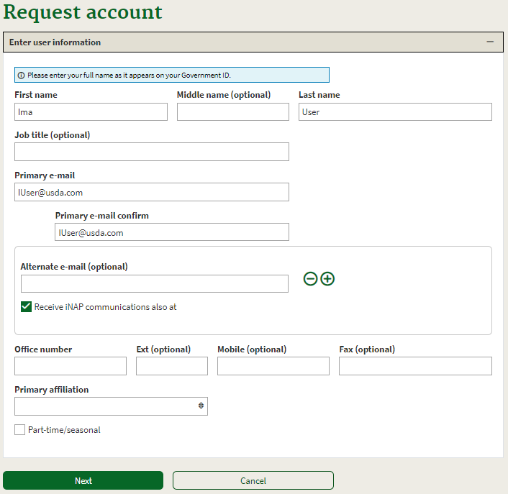

1. Review and accept rules of behavior
   1. Review the rules of behavior
   2. Click the Accept button

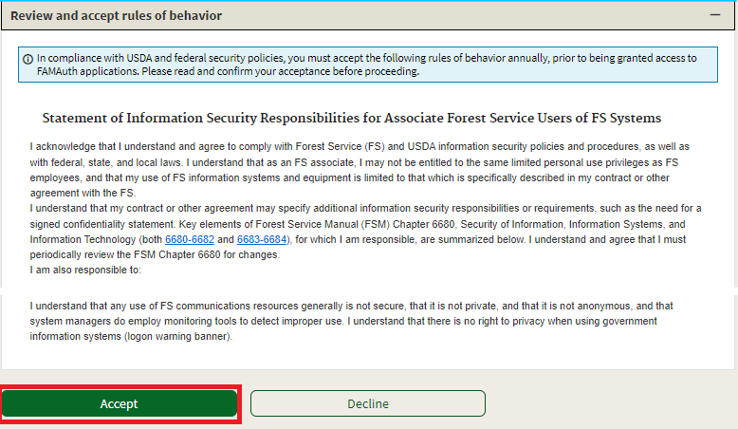

1. Verify the requested application access and roles
   1. The “Application access” drop down will default to the tile that was clicked in step 1
   2. In most cases the “Instance(s)” drop down will default to “PROD”
   3. If the application has roles stored in iNAP they will be presented as check boxes, with default roles already checked. Check any additional roles that you would like to request

1. Enter verification contact information, and select “Submit”

1. If access to another application is not needed, check the I’m not a robot checkbox

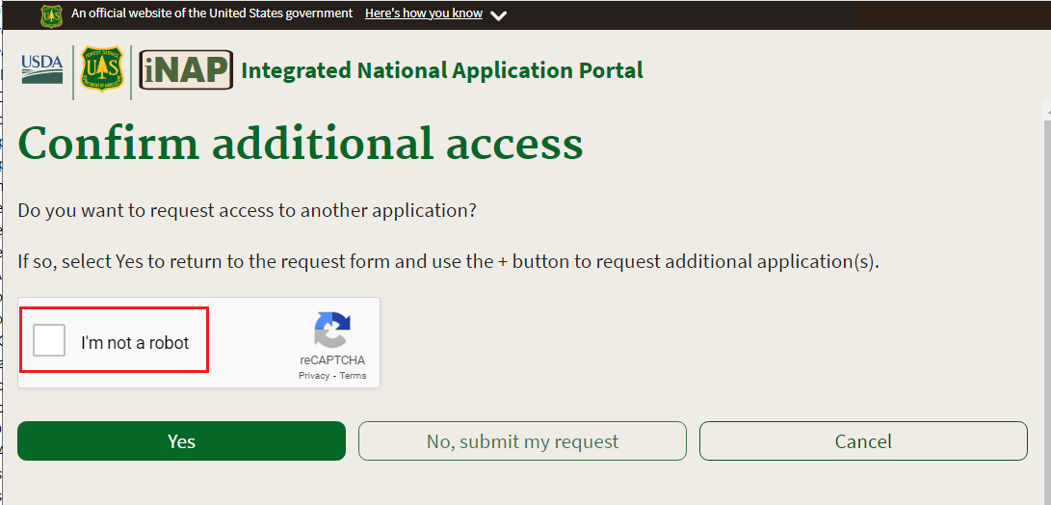

1. Select ‘No, Submit my request’

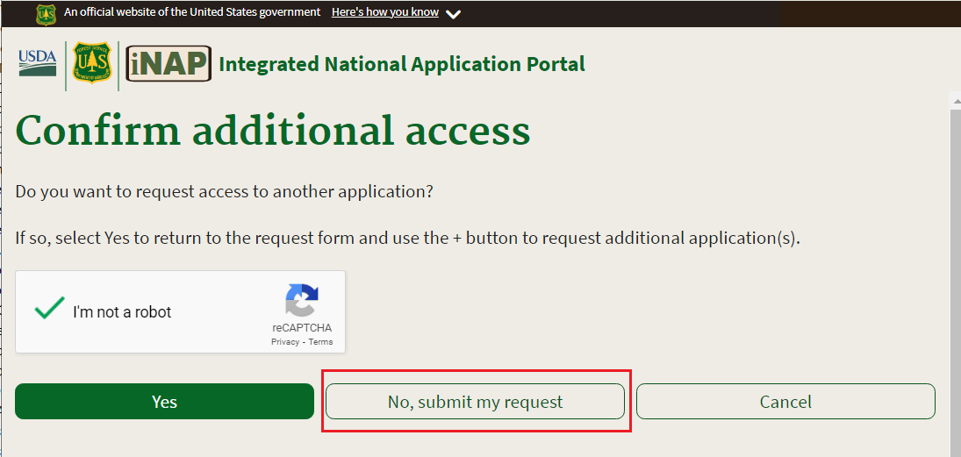

**Note: You will see this page display. You have successfully requested a new iNAP profile that will be connected to your new Login.gov or eAuthentication account.**

**Note: STOP HERE, close your browser, and wait until your account is approved. Once approved you will receive 4 emails.**

1. Upon confirmation and approval of your iNAP request by the approving official you will receive multiple email messages from [donotreply@nwcg.gov](mailto:donotreply@nwcg.gov)

**Note: “OIS” will be replaced with your application in the emails.**

* 1. Application Access for OIS-PROD Approved
  2. Application Role Request for OIS-PROD Approved
  3. iNAP User Account Information (Username) keep this one
  4. iNAP User Account Information (Temporary Password) if you get this temporary password email for iNAP disregard-delete it

**You have successfully created an iNAP profile that is linked to your Login.gov or eAuthentication account. This is a one-time process. The next time you click the application tile (or logo) you wish to use you will be redirected to the FAM application.**